2025 Volunteer Plan

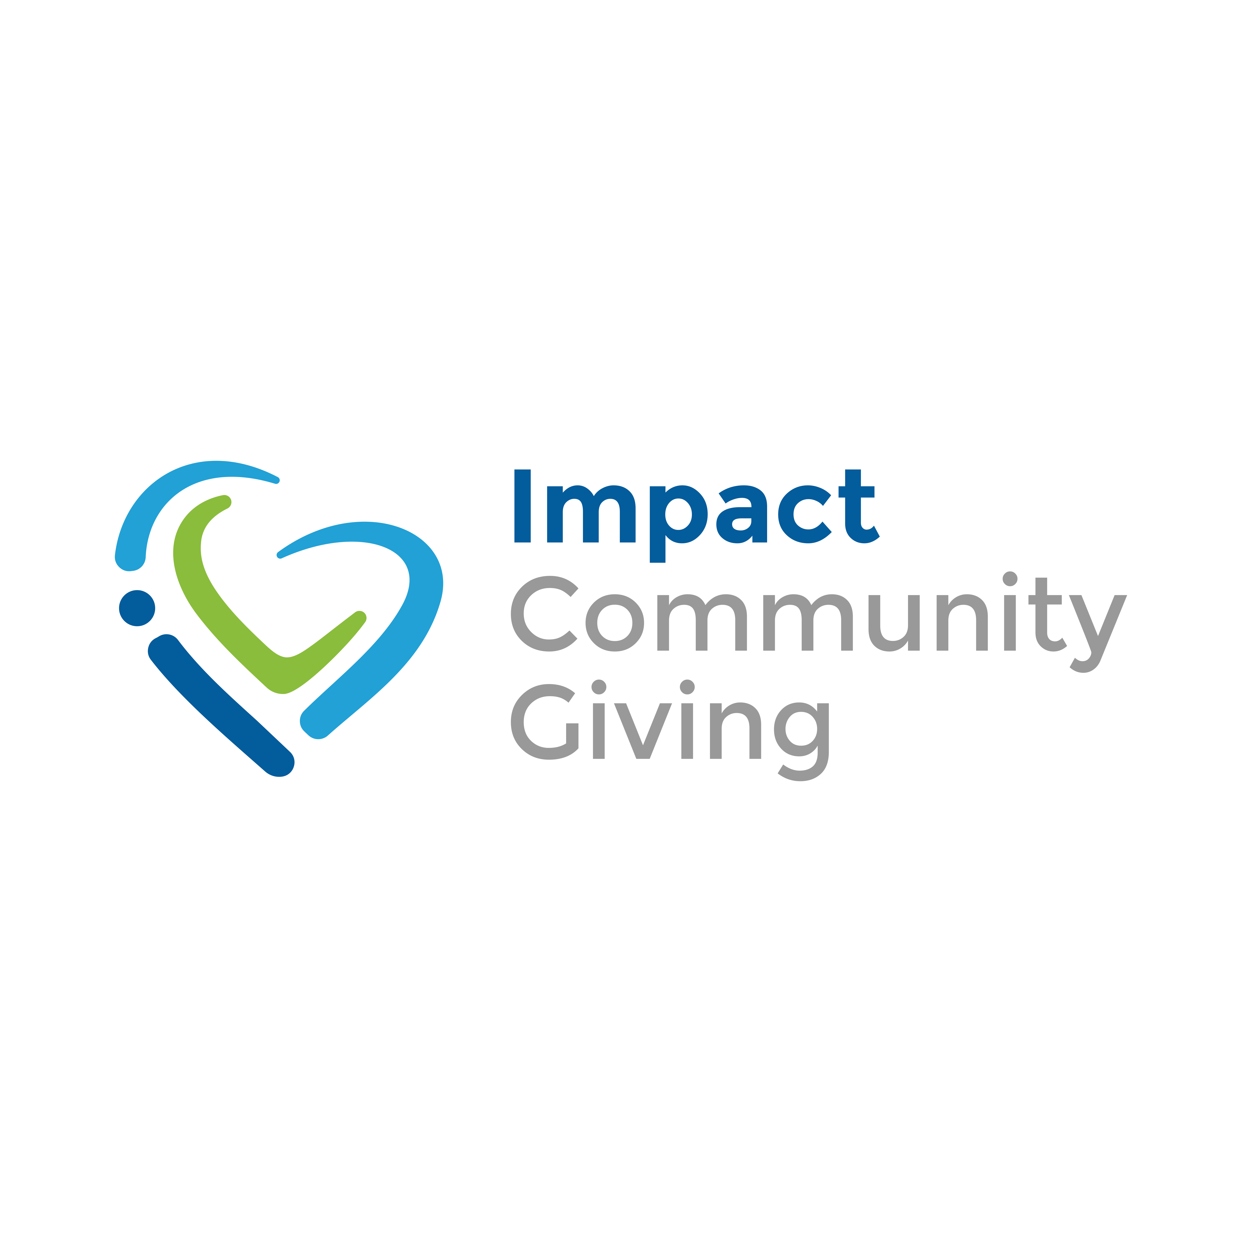

**Organization:**

**Goal 1:**

|  |  |  |
| --- | --- | --- |
| **Action Step** | **Who is Responsible?** | **When is it Due?** |
|  |  |  |
|  |  |  |
|  |  |  |
|  |  |  |
|  |  |  |
|  |  |  |
|  |  |  |

**Goal 2:**

|  |  |  |
| --- | --- | --- |
| **Action Step** | **Who is Responsible?** | **When is it Due?** |
|  |  |  |
|  |  |  |
|  |  |  |
|  |  |  |
|  |  |  |
|  |  |  |
|  |  |  |

**Goal 3:**

|  |  |  |
| --- | --- | --- |
| **Action Step** | **Who is Responsible?** | **When is it Due?** |
|  |  |  |
|  |  |  |
|  |  |  |
|  |  |  |
|  |  |  |
|  |  |  |
|  |  |  |

**Goal 4:**

|  |  |  |
| --- | --- | --- |
| **Action Step** | **Who is Responsible?** | **When is it Due?** |
|  |  |  |
|  |  |  |
|  |  |  |
|  |  |  |
|  |  |  |
|  |  |  |
|  |  |  |

**Business Contact:**

Carla S. Beaudoin, Founder & Chief Impact Officer

[Carla@ImpactCommunityGiving.com](mailto:Carla@ImpactCommunityGiving.com)

(781) 281-8240